MAT 303 Project One Summary Report
Kyle Payne
Kyle.payne2@snhu.edu
Southern New Hampshire University

1. Introduction

We will study the housing_v2.csv data set, a collection of 2692 recent home sales from King County, Washington, which includes Seattle and nearby suburbs. Each record lists the final sale price together with physical characteristics of the house, neighborhood quality measures, and a categorical “view” code that indicates what the property backs up to (0=road, 1=trees, 2=lake).
The real-estate company will use our findings to suggest list prices that are competitive for sellers and attractive for buyers, helping homes move quickly without leaving money on the table.
The analysis will proceed in four stages.
First, we will create exploratory scatterplots of price versus living area square footage and price versus age, then compute Pearson correlation coefficients.
Second, we will fit a first-order multiple regression with price as the response variable and the following predictor variables: living area square footage, upper-level square footage, home age, number of bathrooms, and the three level view factor. We will assess model fit with R² and R²_{adj}, examine residual and Q-Q plots to check assumptions, test each coefficient and overall F statistic, and generate 90% confidence and prediction intervals for two example homes.
Third, we will build and complete a second-order model for price that incorporates school rating and crime rate as quantitative predictors together with their squared terms and interaction. We will evaluate this model with the same diagnostics and produce intervals for two additional scenarios.
Fourth, we will perform a nested models F-test that compares the first-order and second-order specifications to decide whether the quadratic terms provide a statistically meaningful improvement in prediction accuracy.

2. Data Preparation

Key variables that will appear in the correlation study and regression models:
- price – final sale price of the home in US dollars
- sqft_living – finished living area square footage
- sqft_above – square footage of the upper level
- age – age of the home in years at the time of sale
- bathrooms – total number of bathrooms
- view – factor with three levels: 0 = backs up to a road, 1 = backs up to trees, 2 = backs up to a lake
- school_rating – average rating of the public schools that serve the address
- crime – crime incidence per 100,000 residents in the census tract

The cleaned data set contains 2692 rows and 23 columns.

3. Model #1 - First Order Regression Model with Quantitative and Qualitative Variables

Correlation Analysis

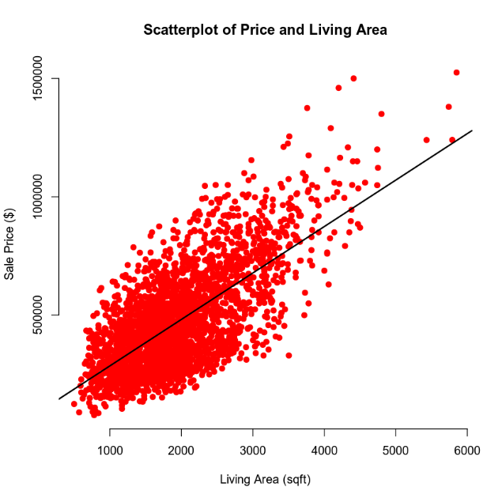

The scatterplot of price versus living area square footage shows a clear upward trend. Larger homes generally command higher selling prices. The Pearson correlation for this pair is r = 0.8895 which confirms a strong, positive linear association. Square footage explains a large share of the variation in price, so it will be an important predictor in the regression model.

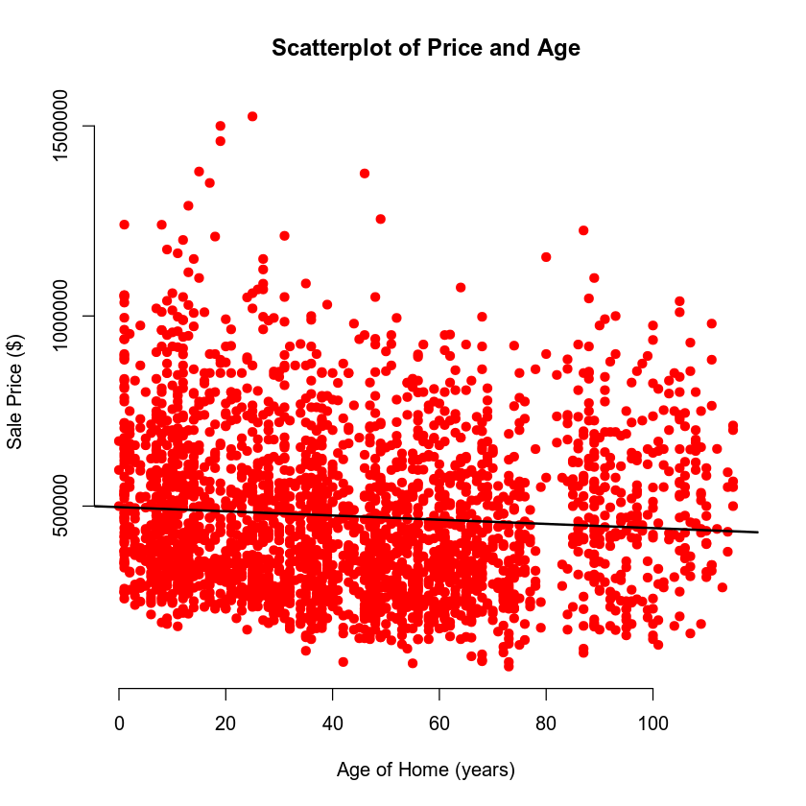

The scatterplot of price against home age shows points scattered widely, and the best-fit line slopes down only a little. The Pearson correlation for this pair is r = -0.0746 which indicates a very weak, negative association. While prices tend to fall a little as homes grow older, age by itself contributes little explanatory power.

In summary, living area square footage emerges as a powerful predictor of price, whereas the age of a house contributes very little explanatory power on its own. Both variables will nevertheless be carried forward into the multiple regression model to see how they interact with other predictors.

Reporting Results

General Form of the Model

$$price= β_{0}+β_{1}\left(sqft_living\right)+β_{2}\left(sqft_above\right)+β_{3}\left(age\right)+β_{4}\left(bathrooms\right)+β_{5}\left(viewTrees\right)+β_{6}\left(viewLake\right)+∈$$

Where $∈$ represends random error and the $β$ values are the unknown slope parameters that describe how price changes with each term.

Prediction Equation with Sample Estimates

$$price=7709+129.3\left(sqft_living\right)+19.51\left(sqf_tabove\right)+1451\left(age\right)+43970\left(bathrooms\right)+167500\left(viewTrees\right)+249000(viewLake)$$

Model Fit

- R² = 0.6029. This means about 60% of the variation in sale price is explained by the six predictors taken together
- R²_{adj} = 0.6020. Essentially the same value after the small penalty for model complexity, confirming that the included variables all contribute meaningful information.

Interpreting Key Coefficients

- Living area square footage coefficient ($β_{1})$ = 129.3. Holding every other variable constant, each additional finished square foot is associated with an average price increase of $129.
- Lake view coefficient ($β_{6})$ = 249,000. Homes that back up to a lake sell on average, for $249,000 more than similar homes that back to a road given that all else is equal.

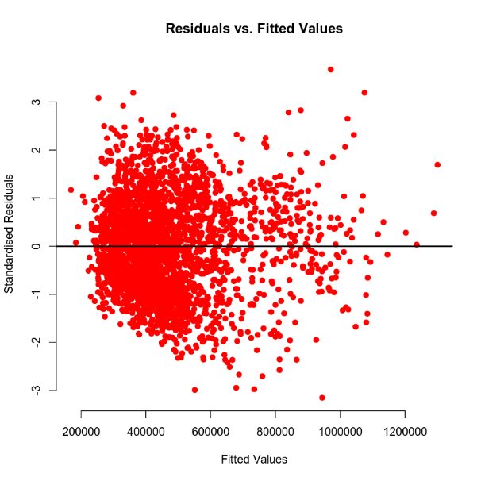

Residuals versus fitted values show no strong curvature. Variability is somewhat wider at very high fitted prices, but the spread remains roughly constant overall, so the constant variance and linearity assumptions are acceptable.

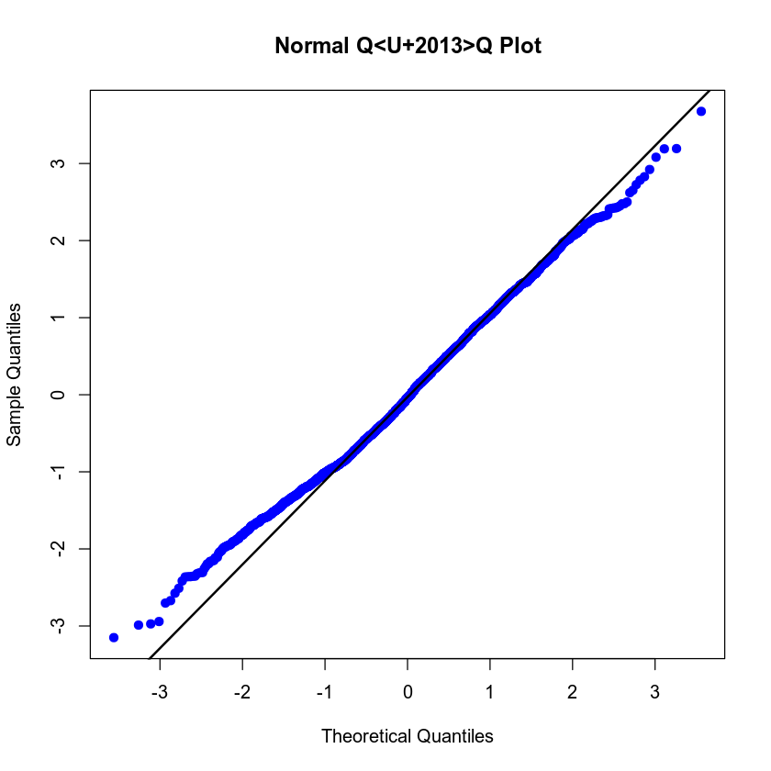

The Normal Q-Q plot exhibits minor tail deviations yet follows the diagonal closely through the center. The residuals are adequately normal for inference.

Evaluating Significance of Model

Overall F-Test

- Null hypothesis (H₀): $β_{1}= β_{2}=…=β_{6}=0$ (no predictor has a linear effect)
- Alternative hypothesis (H_{a}): At least one $β_{i}≠0$

The overall F-test produced an F statistic of 679.3 on 6 and 2685 degrees of freedom, yielding a p-value of < 2.2 X 10⁻¹⁶. Therefore, we reject the null hypothesis and conclude that at a 5% significance level the set of predictors collectively provides strong explanatory power for selling price.

Individual t-test (alpha = 0.05)

Predictor | Coefficient | t | p-value | Decision | Interpretation
sqft_living | 129.3 | 15.92 | 2X10⁻¹⁶ | Reject H₀ | The living area is a significant positive driver of price
sqft_above | 19.51 | 2.62 | 0.00894 | Reject H₀ | Upper-level space adds a small but significant premium
age | 1451 | 12.10 | 2X10⁻¹⁶ | Reject H₀ | Older homes are significantly more expensive in this sample
bathrooms | 43970 | 7.18 | 9.13X10⁻¹³ | Reject H₀ | Additional bathrooms markedly increase price
viewTrees | 167500 | 15.64 | 2X10⁻¹⁶ | Reject H₀ | Tree views add a large premium over road views
viewLake | 249000 | 20.74 | 2X10⁻¹⁶ | Reject H₀ | Lake views add the largest premium
Intercept | 7709 | 0.55 | 0.58495 | Failed to reject | The intercept is not different from zero once predictors are centered at zero, but this has no practical impact on predictions

Every predictor except the intercept is highly significant at the 5% level, supporting their inclusion of the first-order model.

Making Predictions Using Model

Scenario 1: Road View

House specifications: 2150 sqft living area, 1050 sqft upper-level area, 15 years old, 3 bathrooms, and backs to a road. The model’s point prediction is $456,828.
- 90% confidence interval: $440,088 to $473,569. This band estimates the average selling price for all homes that share these exact characteristics. If we could list many such houses, we would expect the mean of their prices to fall in this range 90% of the time.
- 90% prediction interval: $233,663 to $680,093. This much wider band forecasts the price of one future sale. It folds in both the uncertainty in the regression line and the natural house to house variability, so an individual transaction could land anywhere inside this range with 90% confidence.

Scenario 2: Lake View

House specifications: 4250 sqft living area, 2100 sqft upper-level area, 5 years old, 5 bathrooms, and backs to a lake. The model’s point prediction is $1,074,285.
- 90% confidence interval: $1,045,117 to $1,103,454. We are 90% confident that the average selling price of all comparable lake view homes lies within this much narrower window.
- 90% prediction interval: $852,523 to $1,296,048. For a single sale, we need a broader safety net. This interval captures both model uncertainty and the day-to-day volatility of individual deals. With 90% certainty the closing price of one house with these features will fall somewhere in this span.

A confidence interval addresses only the location of the regression line. It reflects how precisely we have estimated the mean response at the specified predictor values. A prediction interval must do more. It must account for the same line uncertainty plus the random scatter of individual observations around the line (the residual variance). Because it combines two sources of variability, the prediction interval is necessarily broader than the confidence interval.

4. Model #2 - Complete Second Order Regression Model with Quantitative Variables

Correlation Analysis
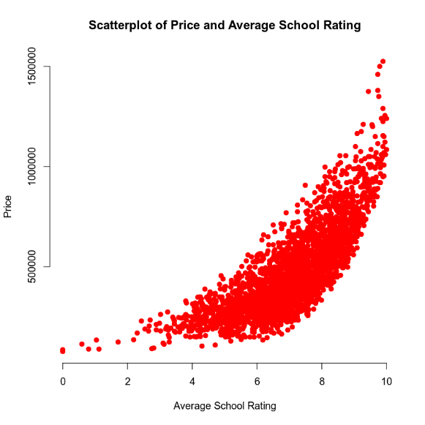
The scatterplot of price and average school rating shows points that rise slowly when school rating is in the middle of the scale, then climb much more steeply once the rating move above about six. This accelerating upward bend tells us that buyers pay an ever larger premium for top rated schools. Because the relationship is clearly curved rather than straight, a model that includes both the rating itself and its squared term with describe the pattern better than a line alone.

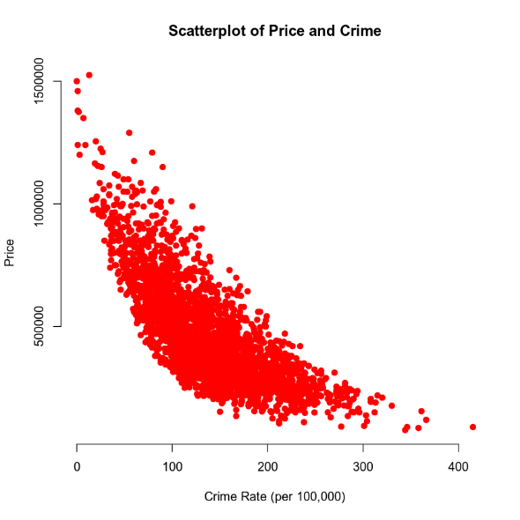
The Scatterplot of price and neighborhood crime rate shows points that fall fast as crime increases from very low levels, but once crime is above roughly 100 incidents per 100,000 people the drop begins to level out. The curve is steep at first and then flattens, which means the effect of each added crime incident is smaller when crime is already high. A quadratic term can capture this diminishing impact because it lets the slope decrease in size as crime grows.

Taken together, the two graphs show a strong curvature in opposite directions. Including squared terms for school rating and for crime rate will allow the regression model to follow these bends and produce more accurate predictions than a strictly linear form.

Reporting Results

General Form of the Complete Second-Order Model

$$price=β_{0}+β_{1}school_{rating}+β_{2}crime+β_{3}{school_{rating}}^{2}+β_{4}{crime}^{2}+β_{5}\left(school_rating*crime\right)+∈$$

Where $∈$ represents random error and the $β$ values are the unknown slope parameters that describe how price changes with each term.

Prediction Equation with the Estimated Coefficients

$$price=733900-73750\left(school_{rating}\right)-3155\left(crime\right)+11650{\left(school_{rating}\right)}^{2}+6.38{\left(crime\right)}^{2}-52.3(school_rating*crime)$$

Model Fit

The model has an R² of 0.8088 and an adjusted R² of 0.8084. About 81% of the total variation in house prices is explained by school quality, crime rate, their squares, and their interaction. The adjusted value is almost the same, so very little explanatory power is lost once the penalty for having five predictors is applied. This confirms that the model offers a strong fit without unnecessary complexity.

Diagnostic Plot

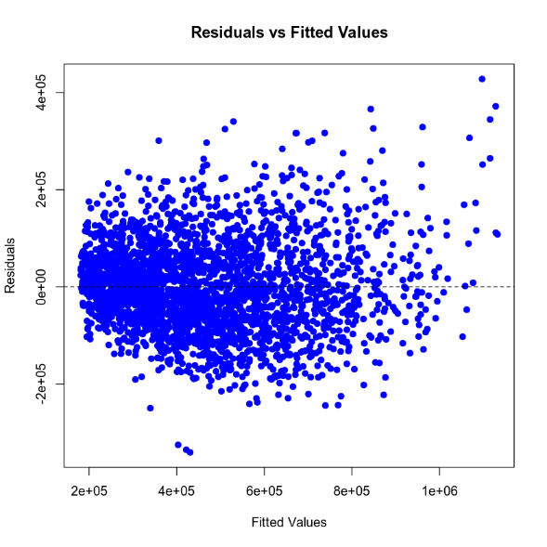

The residuals versus fitted values plot shows a cloud of points that are centered on zero across the full range of fitted prices. The spread is fairly uniform, though the most expensive homes show a slightly wider band. There is no clear curve or funnel, so the assumption of linearity and constant variance appear reasonable.
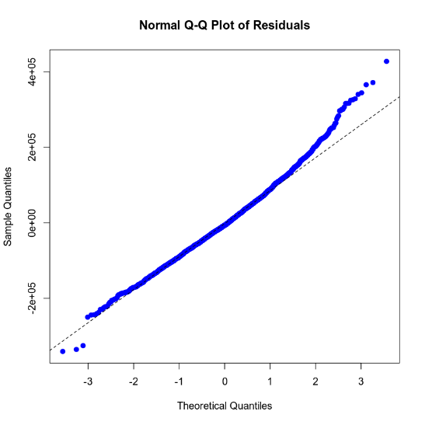

In the normal Q-Q plot the points track the reference line closely through the middle and begin to fan out in the extreme upper tail. Mild departures in the far tails are common with large real-estate data sets and are not serious enough to invalidate the normality assumption. Overall the diagnostics support the use of the model for inference and prediction.

Evaluating Significance of Model

Overall F-Test

- Null hypothesis (H₀): $β_{1}= β_{2}=…=β_{5}=0$ (no predictor has a linear effect)
- Alternative hypothesis (H_{a}): At least one $β_{i}≠0$

The F statistic is 2272 on 5 and 2686 degrees of freedom with a p-value less than 2X10⁻¹⁶. Because the p-value is far below 0.05 we reject the null hypothesis and conclude that, taken together, the predictors provide a statistically significant explanation of price.

Individual t-test (alpha = 0.05)

Predictor | Coefficient | p-value | Conclusion
school_rating | -73,750 | 0.000406 | Significant
crime | -3,155 | 1.9X10⁻⁹ | Significant
$${school_rating}^{2}$$ | 11,650 | <2X10⁻¹⁶ | Significant
$${crime}^{2}$$ | 6.38 | <2X10⁻¹⁶ | Significant
school_rating*crime | -52.3 | 0.282 | Not significant

For each significant term the null hypothesis states that its coefficient quals zero, and the alternative states that the coefficient differs from zero. P-values below 0.05 lead us to reject the null hypothesis. The interaction term between school rating and crime has a p-value of 0.2828, so its effect is not statistically different from zero at the five percent level. All other terms are highly significant and should remain in the model.

Making Predictions Using Model

Home in a High-Quality, Low-Crime Neighborhood

For a house located in an area where the average school rating is 9.80 and the crime rate is 81.02 incidents per 100,000 residents, the model predicts a selling price of about $874,500.
- A 90% confidence interval for the mean price of all homes with these exact neighborhood characteristics runs from $863,900 to $885,300. This interval reflects only the uncertainty in estimating the regression line. If we could list many such homes, we are 90% confident that their average selling price would fall inside this range.
- A 90% prediction interval for one individual sale extends from $721,600 to $1,027,400. This wider band combines the same line uncertainty with the natural home-to-home variation that remains after accounting for school quality and crime. We can be 90% certain that a single transaction with these neighborhood traits will close somewhere between those dollar amounts.

Home in a Mid-Quality, High-Crime neighborhood

For a house situated where the average school rating is 4.28 and the crime rate is 215.50 incidents per 100,000 residents the model predicts a selling price of about $199,700.
- The 90% confidence interval for the mean price of all comparable homes is $191,800 to $207,700. If many houses shared these neighborhood conditions, their average price would land in this range nine times out of ten.
- The 90% prediction interval for a single sale stretches from $48,100 to $352,400. Because individual sales vary widely, especially in the lower-priced, higher-crime areas, the prediction interval is much broader. We can be 90% confident that one particular home with these neighborhood ratings will sell for a price somewhere in those bounds.

5. Nested Models F-Test

Reporting Results

General Form of the First-Order Model with Interaction
$price=β_{0}+β_{1}(school_rating)$+ $β_{2}(crime)$+ $β_{3}\left(school_rating*time\right)+∈$

Where $∈$ represends random error and the $β$ values are the unknown slope parameters that describe how price changes with each term.

Estimated Prediction Equation
$$price=-412233+155560\left(school_{rating}\right)+2230\left(crime\right)-565(school_rating*crime)$$

Model Fit

The model explains about 80% of the variation in sales price. R² is 0.7995 and the adjusted R² is 0.7993, so almost all the explanatory power remains after accounting for the three predictors.

Evaluating Significance of Mode

Overall F-Test

- Null hypothesis (H₀): $β_{1}= β_{2}=β_{3}=0$ (no predictor has a linear effect)
- Alternative hypothesis (H_{a}): At least one $β_{i}≠0$

The F statistic is 3573 with 3 and 2688 degrees of freedom and a p-value smaller than 2X10⁻¹⁶. Because the p-value is far below 0.05, we reject the null hypothesis. The set of predictors, taken together, provides a statistically significant explanation of house prices.

Individual t-test (alpha = 0.05)
Predictor | Coefficient | p-value | Decision | Interpretation
school_rating | 155,560 | <2X10⁻¹⁶ | Significant | Higher school ratings raise price
crime | 2230 | <2X10⁻¹⁶ | Significant | In isolation, higher crime slightly raises price
school_rating*crime | -565 | <2X10⁻¹⁶ | Significant | The positive effect of school rating on price weakens as crime rises (and vice-versa)

Each term has a p-value well below 0.05, so all three predictors contribute meaningfully to the first-order model.

Model Comparison

When two regression equations are compared, the reduced model is the simpler one that omits a set of terms, whereas the complete model contains every term under consideration. In a nested models F-test we ask whether the additional terms in the complete model provide a meaningful improvement in fit. If they do not, the reduced model is preferred because it explains the data just as well with fewer parameters.
For this comparison the reduced model is the first-order equation with an interaction between school quality and crime.

Reduced Model (First-Order)
$$price=β_{0}+β_{1}\left(school_rating\right)+β_{2}\left(crime\right)+β_{3}\left(school_rating*crime\right)+∈$$

Using the estimates from model 3 the fitted equation becomes
$$price=-410223+155560\left(school_{rating}\right)+2230\left(crime\right)-565(school_rating*crime)$$

Complete Model (Second-Order)
$price=β_{0}+β_{1}(school_rating)$+ $β_{2}(crime)$+ $β_{3}\left(school_rating*crime\right)+β_{4}{(school_rating)}^{2}+β_{5}{(crime)}^{2}$

Using the estimates from model 2 the fitted equation becomes
$$price=733900-73750\left(school_rating\right)-3155\left(crime\right)-52.3\left(school_rating*crime\right)+11650{\left(school_rating\right)}^{2}+6.38{(crime)}^{2}$$

The ANOVA comparison of the two nested models reports an F-statistic of 65.21. The associated p-value is 2.23X10⁻²³.

Interpretation of the Test

- Null hypothesis (H₀): the two quadratic coefficients are both zero, so the simpler first-order model is sufficient.
- Alternative hypothesis (H_{a}): at least one of the quadratic coefficients differs from zero, meaning the second-order terms improve predictive accuracy.

Because the p-value is extremely smaller than the 0.05 significance level, we reject the null hypothesis. In practical terms, adding the squared terms for school quality and crime rate yields a statistically significant gain in explanatory power. Therefore, the complete second-order model is the appropriate choice for predicting house prices.

6. Conclusion

The statistical evidence points to the complete second-order regression as the better tool for predicting house prices in King County. Adding the squared terms for school quality and crime rate lifted the adjusted R squared from about 80% to just over 81% and the nested F-test showed that this improvement is far too large to attribute it to chance. In plain language, prices rise slowly at first and then surge for homes near the very best schools, while the drop in price from crime is steep in the safest neighborhoods and then tapers off once crime is already high. Those curved patters cannot be captured by a straight-line model no matter how the interaction term is tuned, so the second-order equation provides a meaningfully sharper picture of the market.
For the real-estate firm this analysis has two practical payoffs. First, it delivers a pricing formula that explains more than eighty percent of the variation in sale prices using only two easy to obtain neighborhood measures. That makes it quick to estimate a competitive list price for a new property and to defend that price to clients with clear, data-based reasoning. Second, the model supplies both confidence intervals and prediction intervals. Confidence intervals show management where the average price for similar homes should land, helping to set consistent pricing guidelines, while the wider prediction intervals give agents a realistic range for individual negotiations. Together, these tools support faster listings, more accurate expectations, and smoother transactions for sellers and buyers alike.

